1. Project Structure

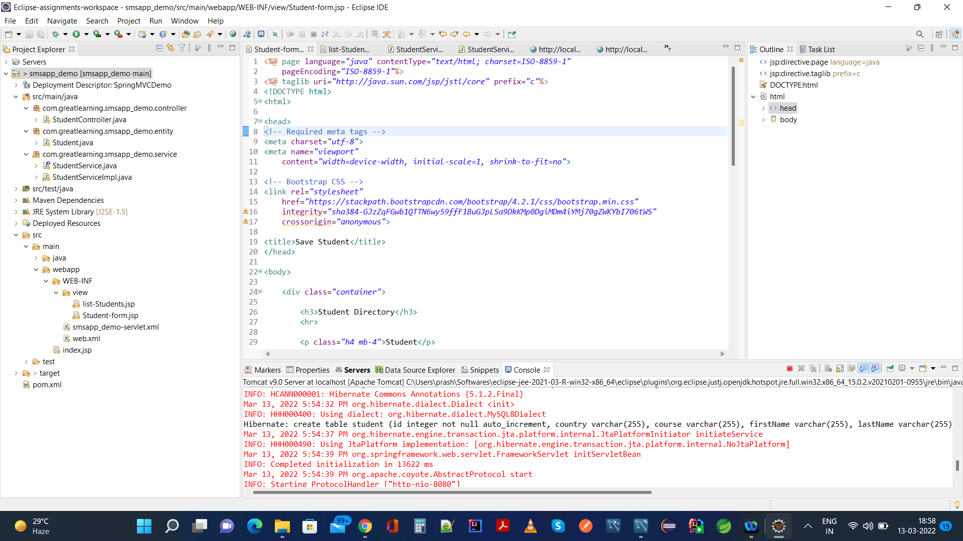

1. Database sms which initially do not have sms table

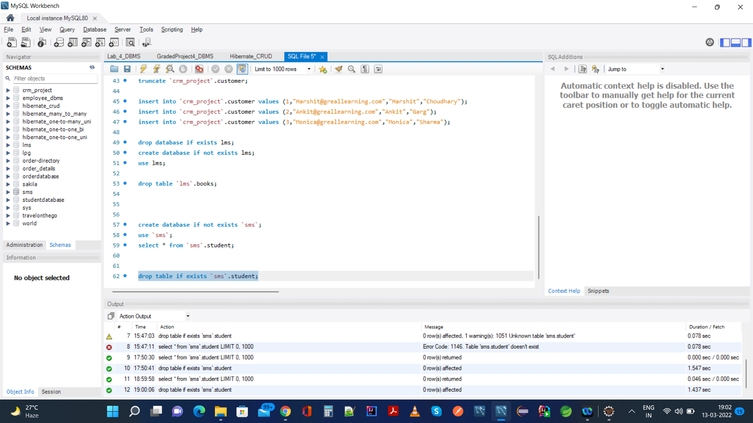

1. Running smsapp_demo project, it will create table as shown in console log below,

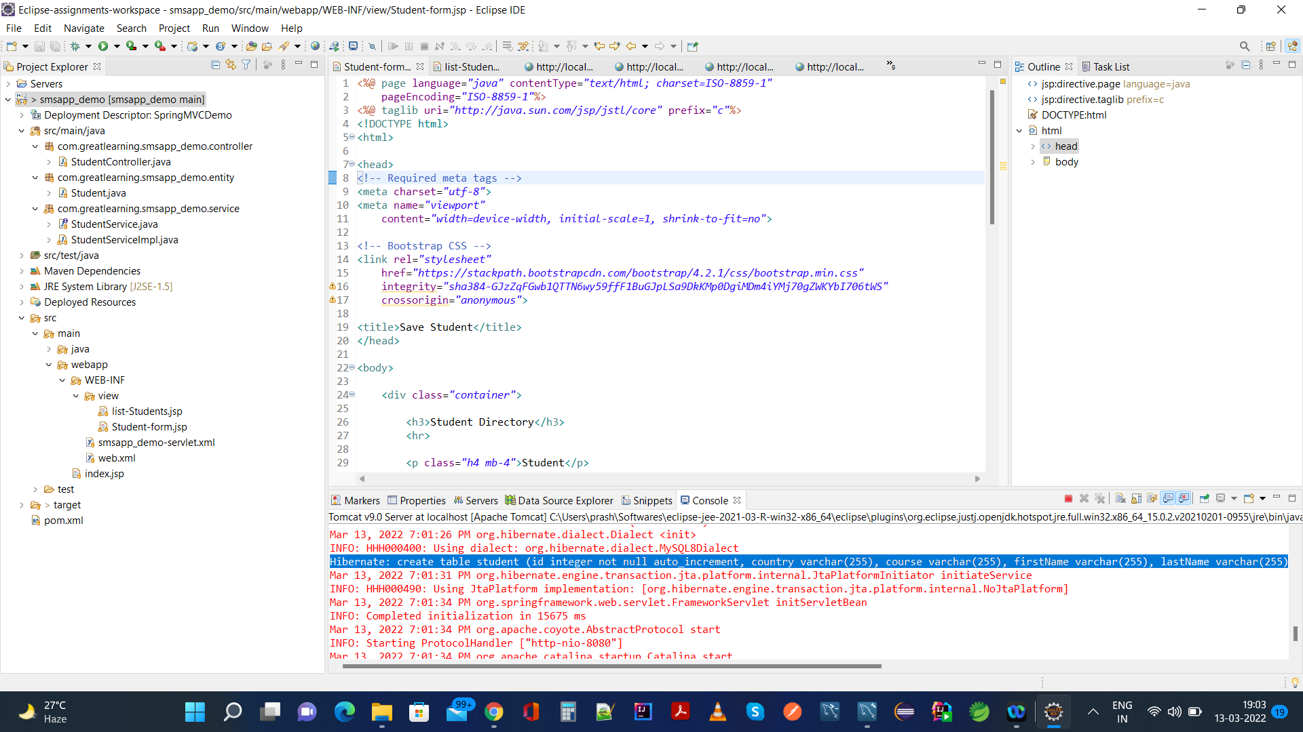

1. Student table is now created in sms database schema that is initially empty as seen below,

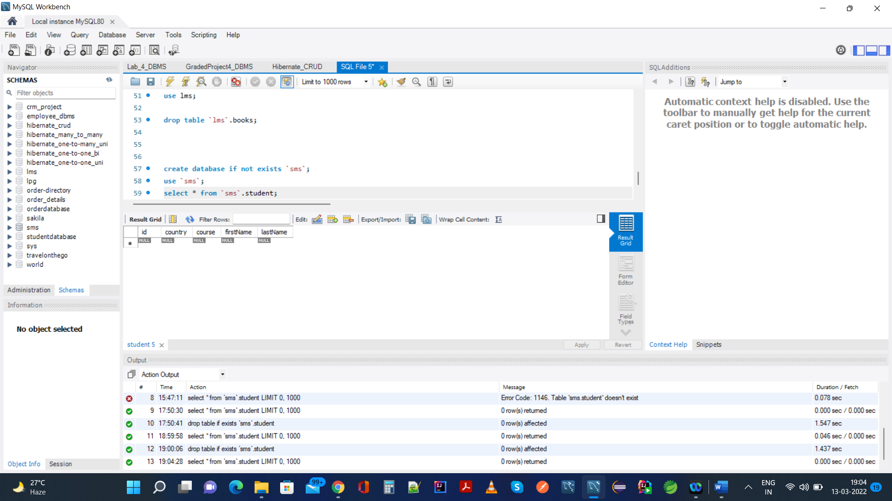

1. Going into application smsapp_demo on browser using url: <http://localhost:8080/smsapp_demo/student/list>

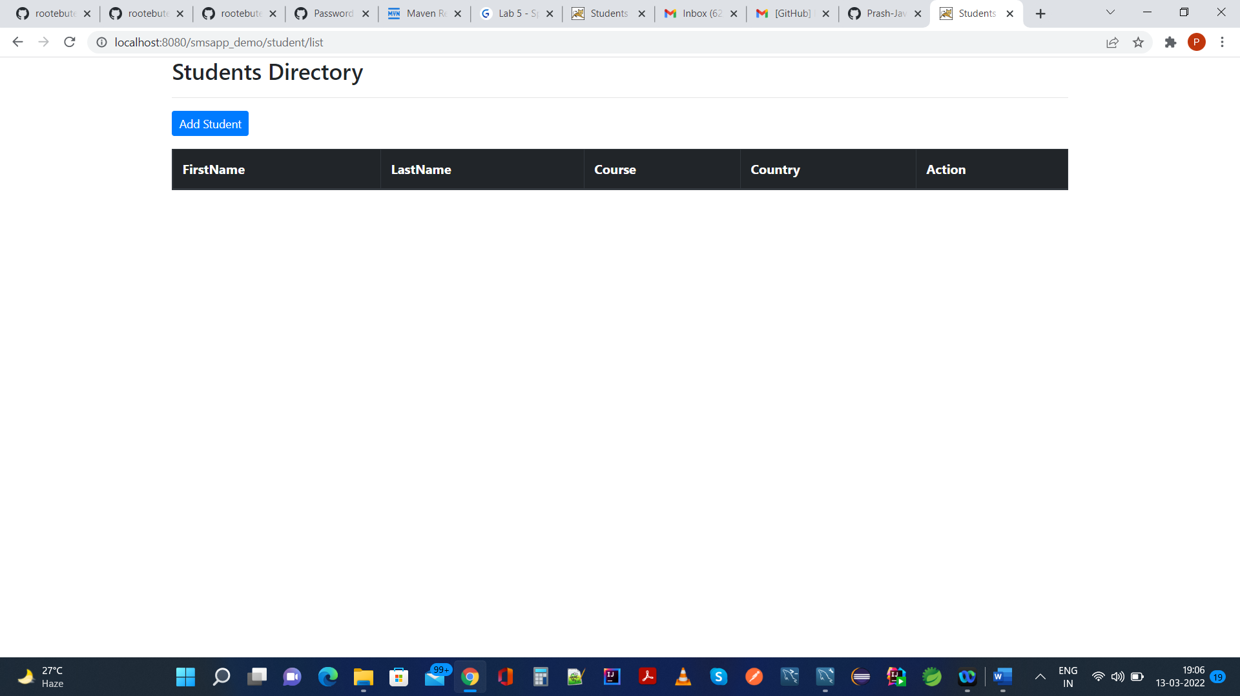

1. Now Add Student Using Button ciontaining href as below,

<http://localhost:8080/smsapp_demo/student/showFormForAdd>

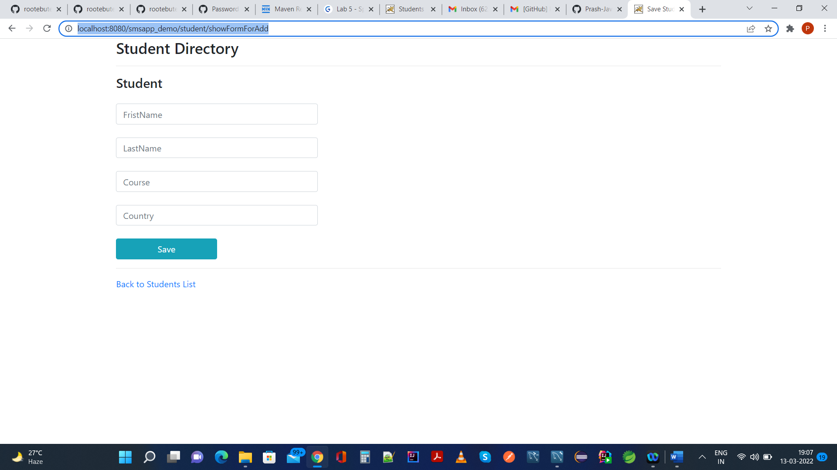

1. Actual Addition of Student is seen below in application ui at <http://localhost:8080/smsapp_demo/student/showFormForAdd>

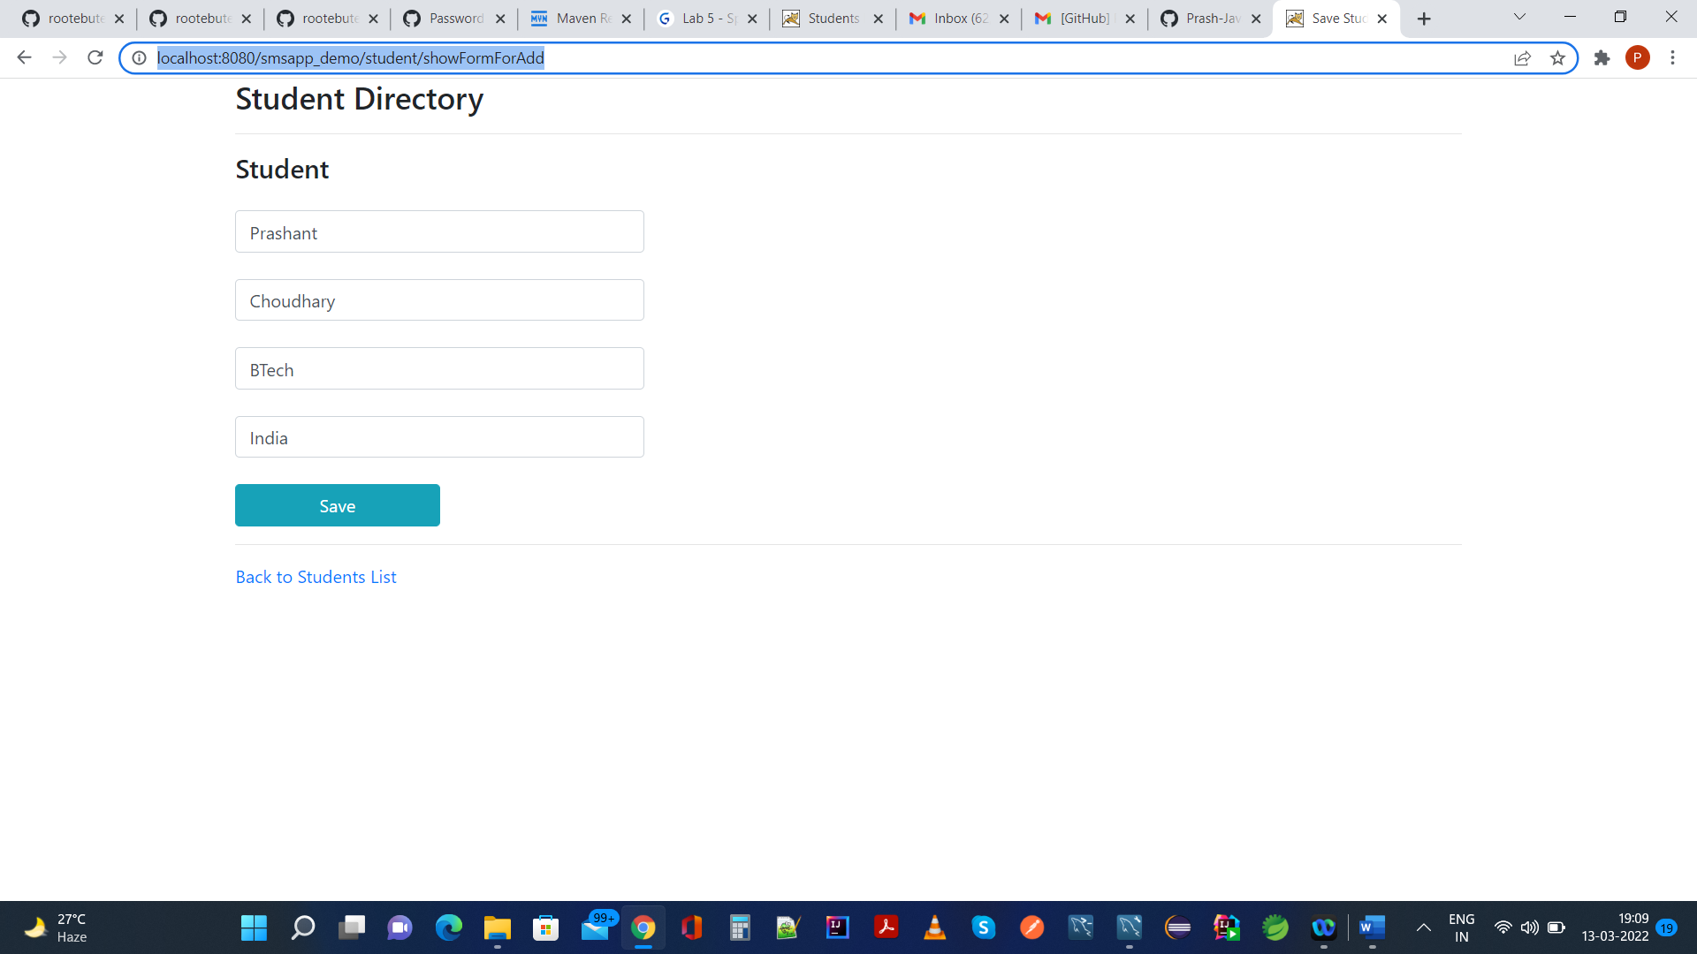

8) Saving above form using Post request will redirect to /student/list

<http://localhost:8080/smsapp_demo/student/list>

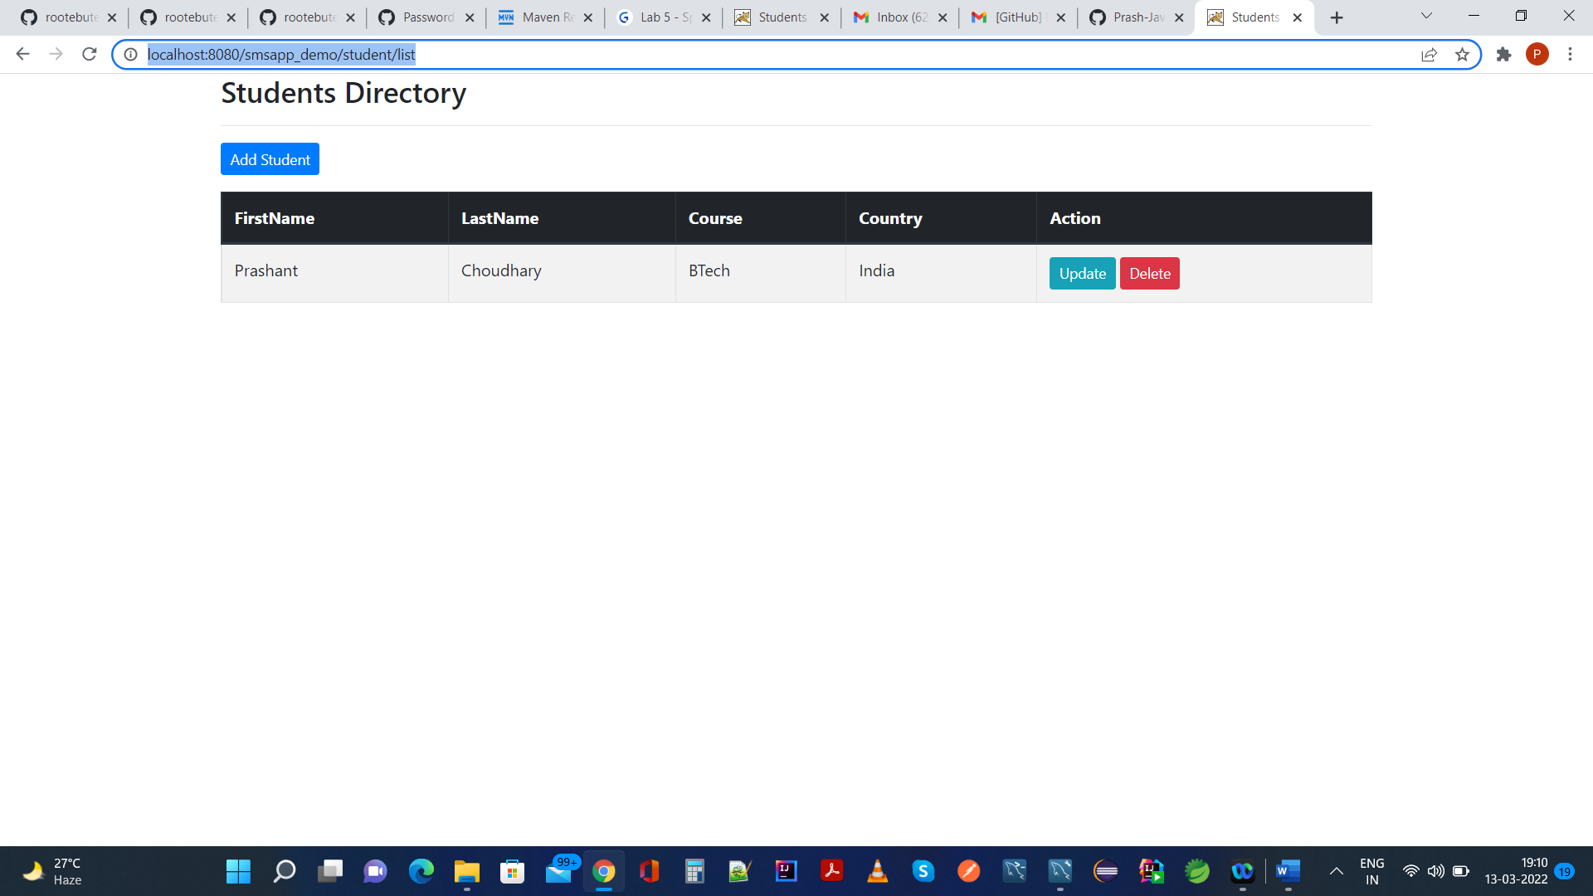

Same will be reflected in database also as seen below,

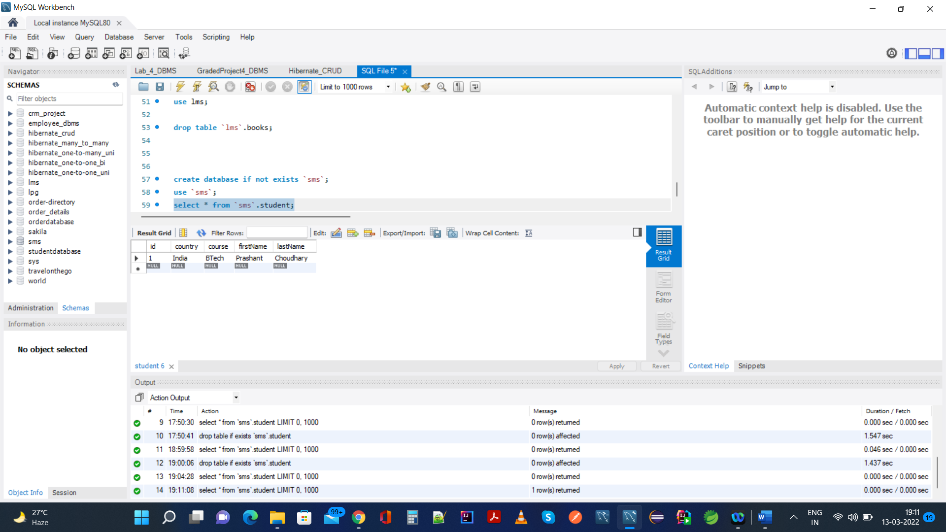

Adding Another Student using the same process:

<http://localhost:8080/smsapp_demo/student/showFormForAdd>

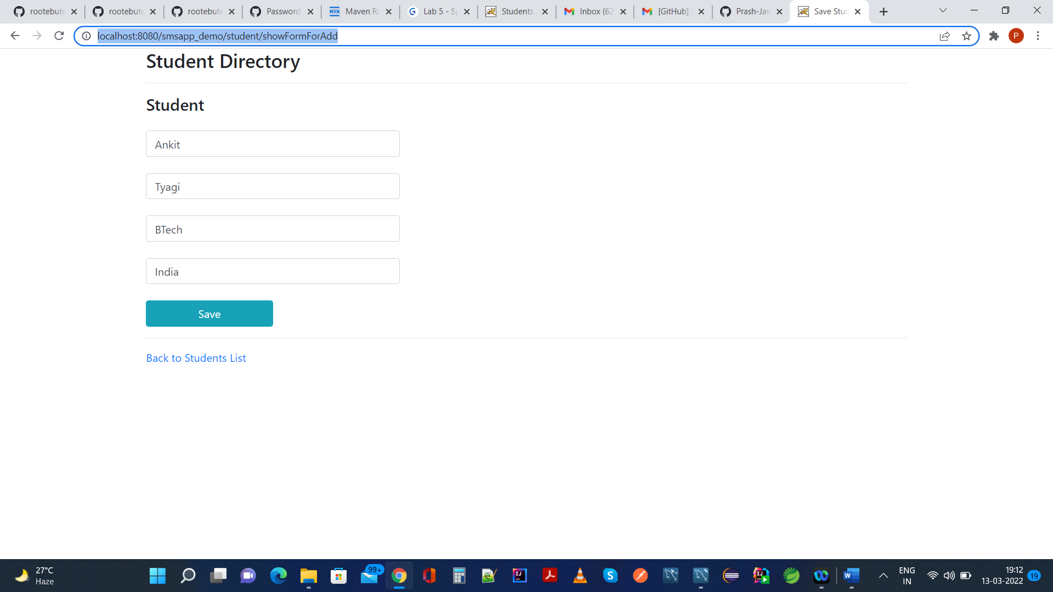

Saved data will redirect us to /student/list,

<http://localhost:8080/smsapp_demo/student/list>

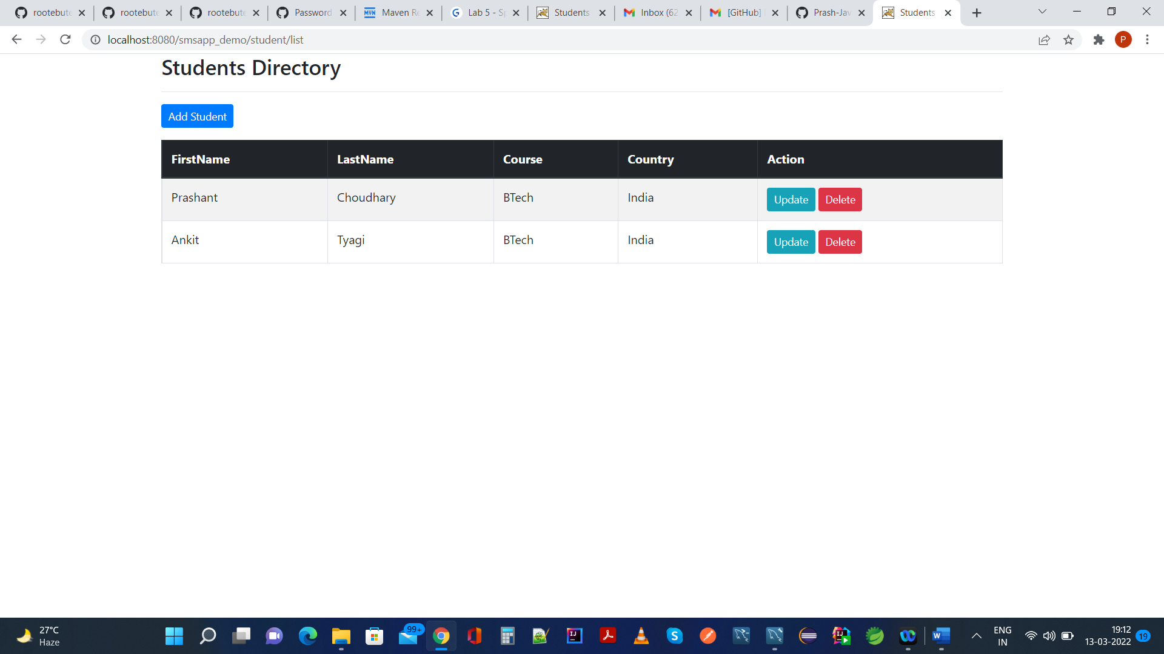

Same will be reflected in mysql database also as seen below,

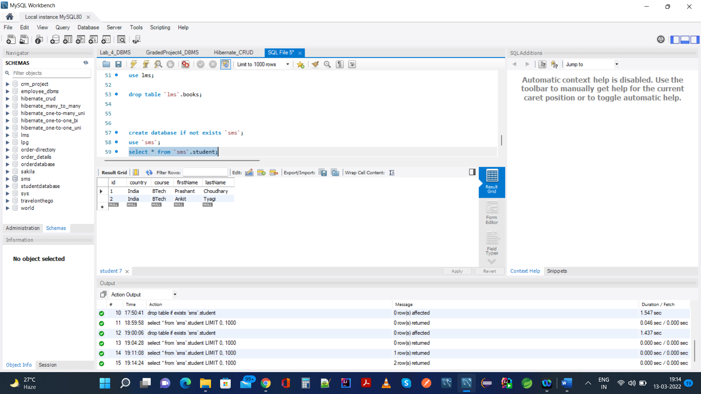

10.) Performing Update Operation In 1st Row as seen below in UI,

<http://localhost:8080/smsapp_demo/student/showFormForUpdate?studentId=1>

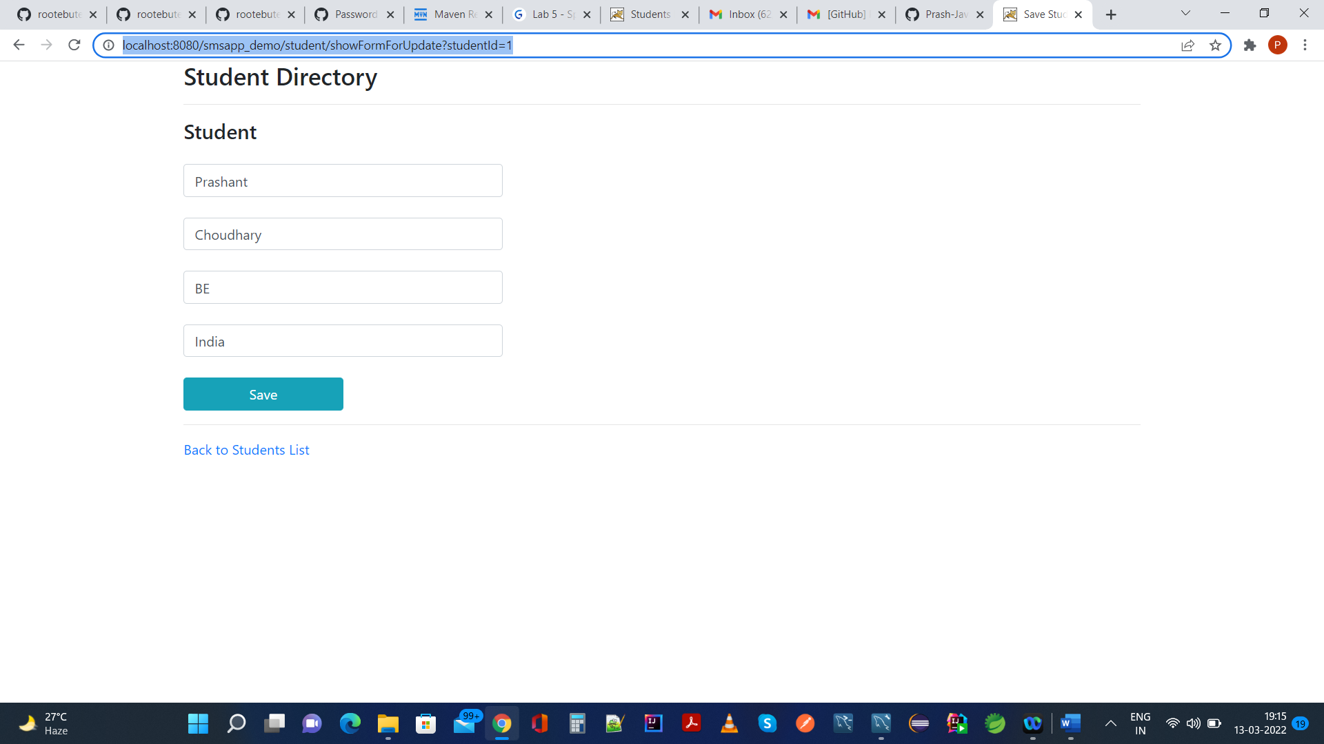

Course in 1st Row is upodated to BE from existing BTech, and navigated back

<http://localhost:8080/smsapp_demo/student/list>

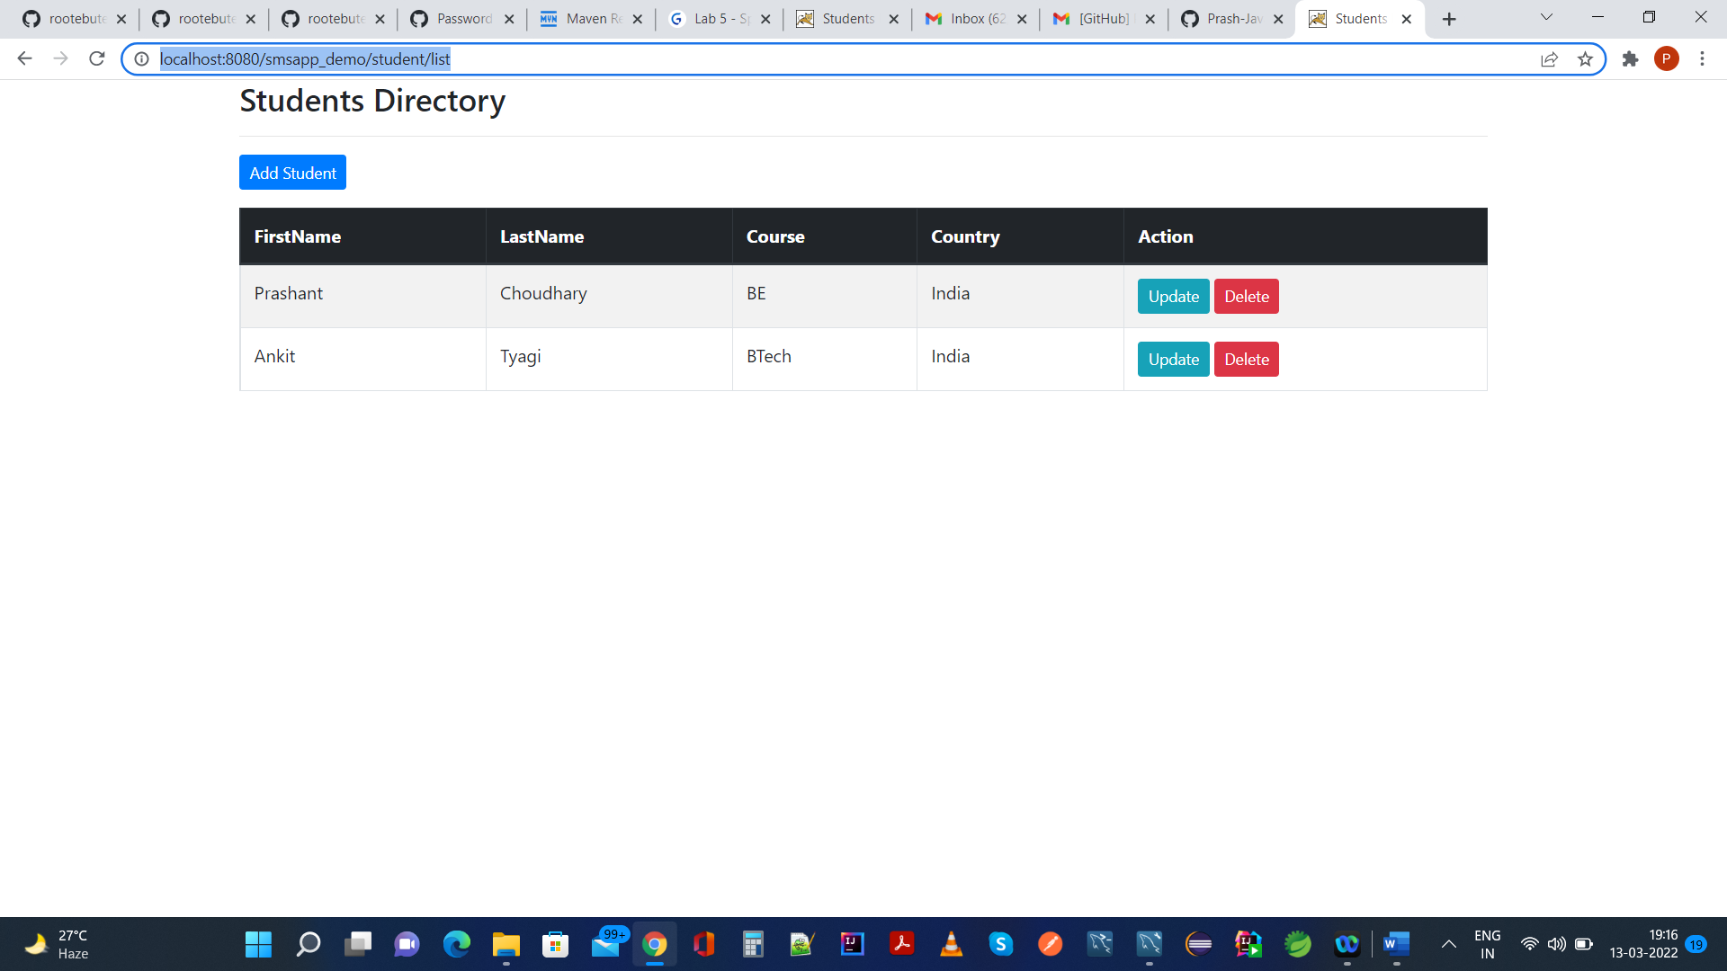

Same is reflected in mysql database also as seen below,

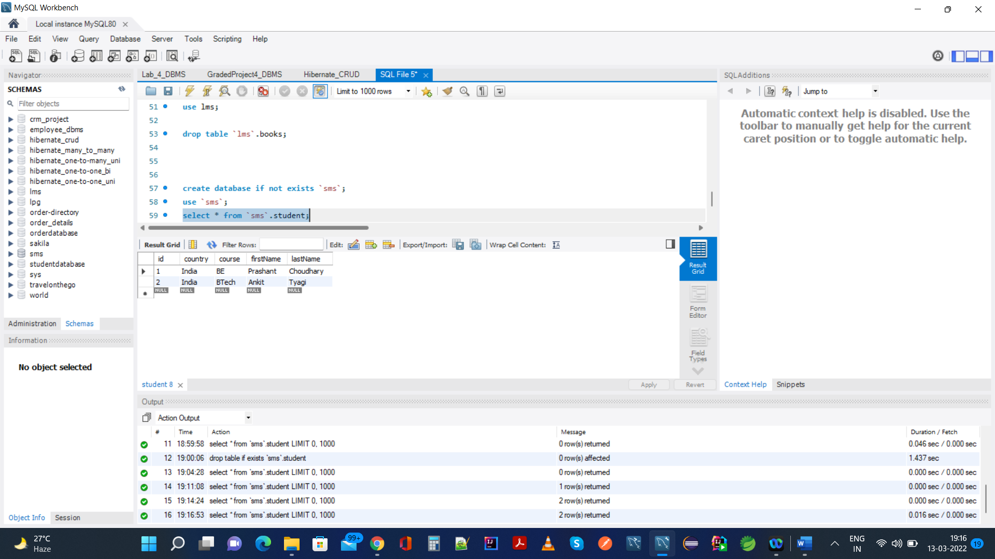

11.) Back To List: Clicking on Update button on 2nd row and then clicking back to list link:

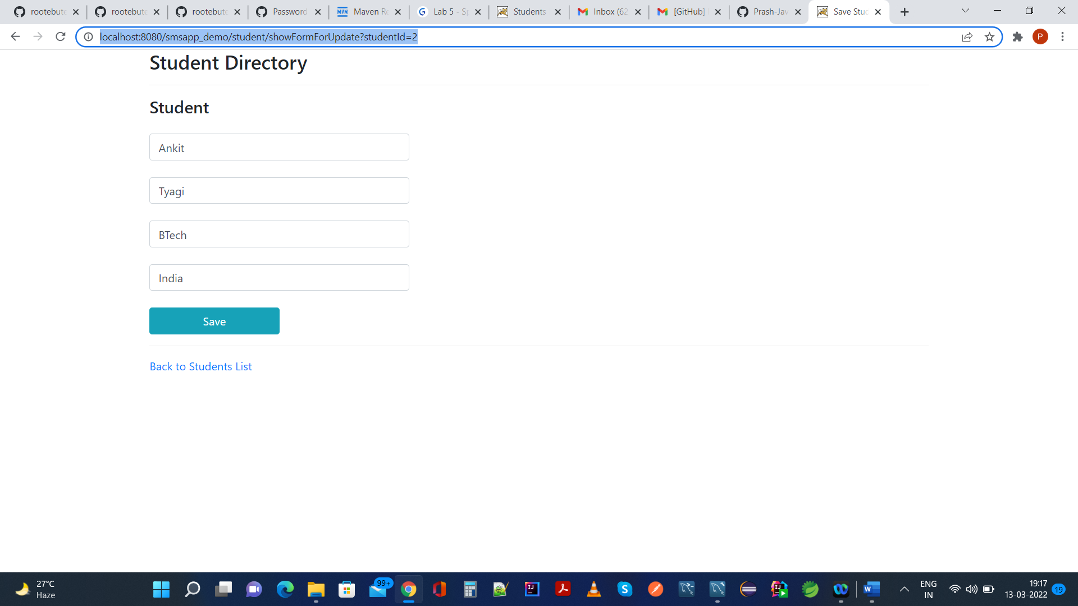

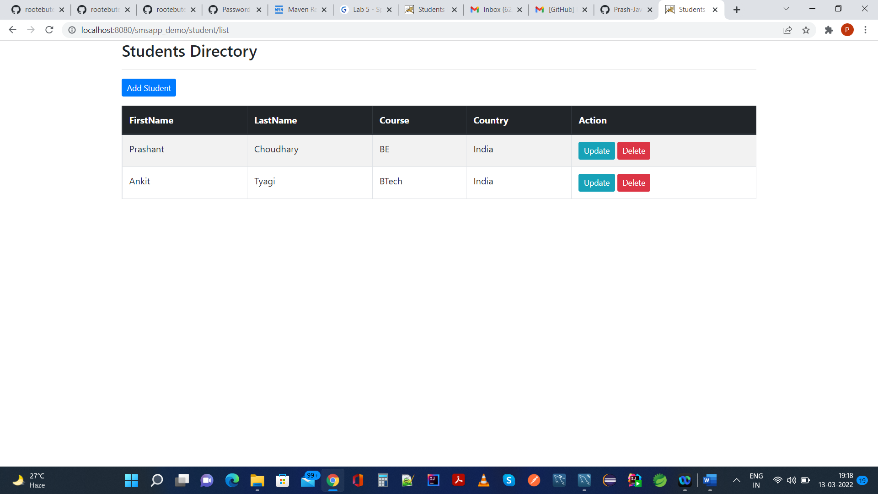

12.) Deleting 2nd row from UI: Popup will come which is implemented as part of onclick event in jsp view

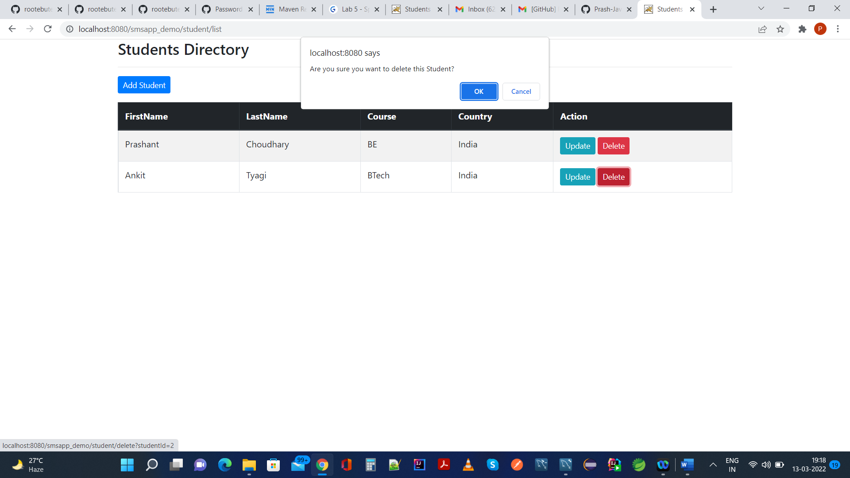

Clicking on ok will delete 2nd row as seen below:

<http://localhost:8080/smsapp_demo/student/list>

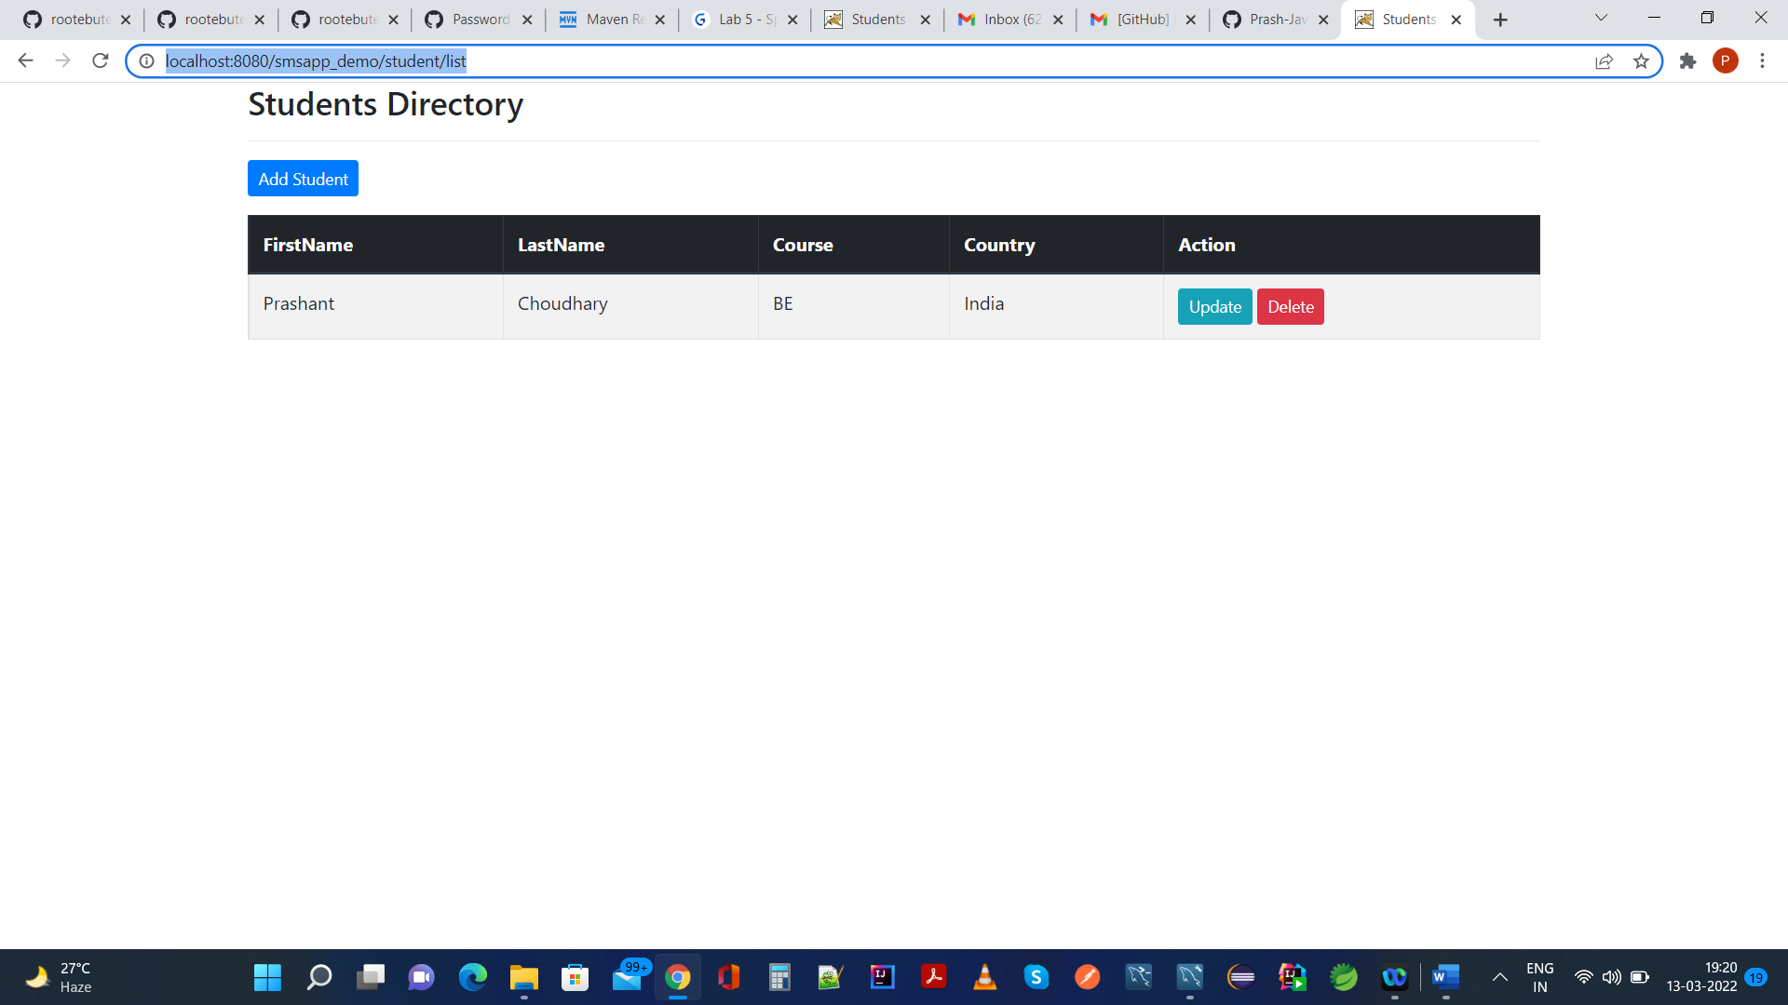

Same is reflected in mysql database as well as seen below,

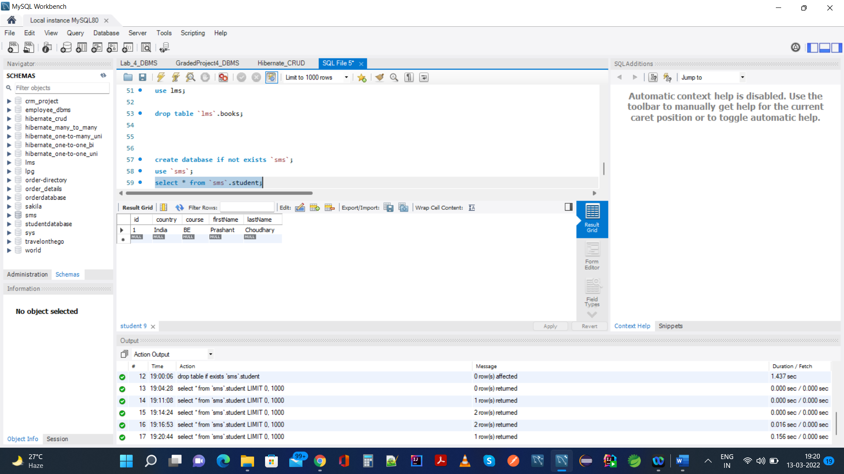

13.) Queries Executed In Performing All CRUD Operations:

